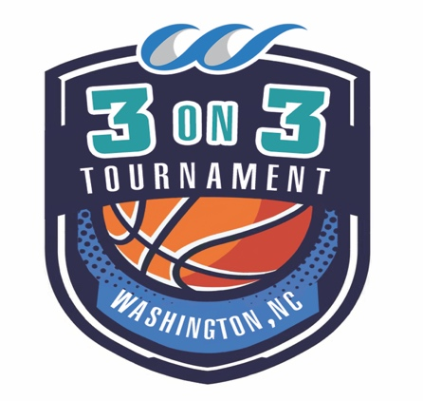
Presented By:
Hoops on the Pamlico
3 on 3 Co-ed Basketball Tournament
Saturday, October 5 @9:00am
Check in at 8:00am
Stewart Parkway in Downtown Washington
$5.00 per player entry fee – minimum of 3 per team and maximum of 8
(Captain will collect all money and turn in with form. Form not valid without payment)

The tournament will be for children (boys and girls) ages 9 through adults. We will have a maximum of 36 teams and 4 teams per age group. It will be round robin format. Teams will be entered on a first come first served basis. Every team must have a captain. The captain will be responsible for turning in team registration and money and also relaying applicable information to team members.

Team Name: ____________________________________________
Team Captain’s Name: ____________________________________
Captain’s Phone: _________________________________________
Captain’s Email: _________________________________________

CIRCLE YOUR AGE DIVISION BELOW
(Captain responsible for gathering proof of age – August 31, 2019 is cut off for age)

9U & 10U 11U & 12U 13U & 14U 15U & 16U 17U & 18U

19 & up 30’s 40’s 50 & UP

Name Date of Birth Shirt size (Youth S,M,L
Or adult S,M,L,XL, XXL)

All players and a parent/guardian for each player under 18 years old, must sign this waiver of liability to participate in this 3 on 3 basketball tournament. By his/her signature below or by the participant’s parent/guardian signature, the participating individual voluntarily agrees to assume and/or incur all risks of loss, impairment, damage or injury that may be sustained or suffered by participation in the event whether or not the result in whole or in part of the acts of omission, negligence or other unintended fault of the event sponsor or property owners. Additionally, by his/her signature below, or by the signature of the participant’s parent/guardian, the participating individual voluntarily waives all rights to ownership to any written, photographic or video use of the participating individual’s name, image or representation, and hereby grants permission for the publication, announcement and/or distribution thereof by the sponsor. The Assumption of Risk and Waiver release applies to the Washington-Beaufort County Chamber of Commerce, Washington Tourism Development Authority and the City of Washington and in addition any and all sponsors of the event and all of the officers, directors, staff, employees and volunteers and/or representation.

Player’s Signature:
Parent/Guardian Signature:
Emergency Contact:
Phone # for Emergency Contact:

Player’s Signature:
Parent/Guardian Signature:
Emergency Contact:
Phone # for Emergency Contact:

Player’s Signature:
Parent/Guardian Signature:
Emergency Contact:
Phone # for Emergency Contact:

Player’s Signature:
Parent/Guardian Signature:
Emergency Contact:
Phone # for Emergency Contact:

Player’s Signature:
Parent/Guardian Signature:
Emergency Contact:
Phone # for Emergency Contact:

Player’s Signature:
Parent/Guardian Signature:
Emergency Contact:
Phone # for Emergency Contact:

Player’s Signature:
Parent/Guardian Signature:
Emergency Contact:
Phone # for Emergency Contact:

Player’s Signature:
Parent/Guardian Signature:
Emergency Contact:
Phone # for Emergency Contact:

Completed registration form and waiver with checks (cash also accepted) made payable to WBC Chamber of Commerce must be received by Friday, September 13. (If registration form is not received by this date you may not receive a t-shirt). They can be delivered to the Chamber at 102 Stewart Parkway in Downtown Washington or mailed to WBC Chamber, PO Box 665, Washington, NC 27889.

For more information call Robin at the Chamber at 252-946-9168 or email rmckeithan@wbcchamber.com

